Hardware Requirements
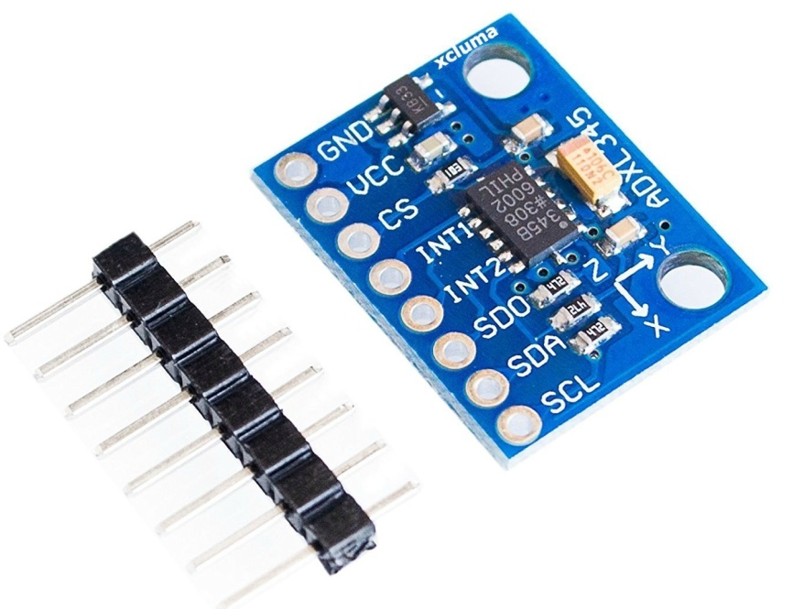
- Accelerometer
Fig 1 Accelerometer
An accelerometer is a device that measures the vibration, or acceleration of motion, of a structure. The force caused by vibration or a change in motion (acceleration) causes the mass to “squeeze” the piezoelectric material which produces an electrical charge that is proportional to the force exerted upon it.

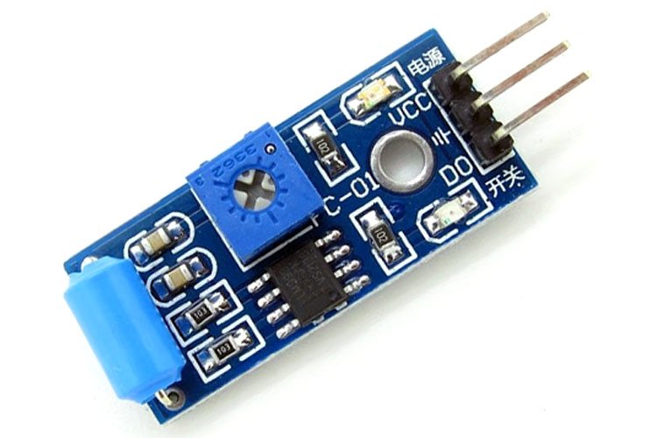
Vibration Sensor SW-420
Fig 2 Vibration Sensor
The other important sensor is Vibration sensor. the model number is SW-420 for the given vibration sensor. the working of the vibration sensor is very simple.

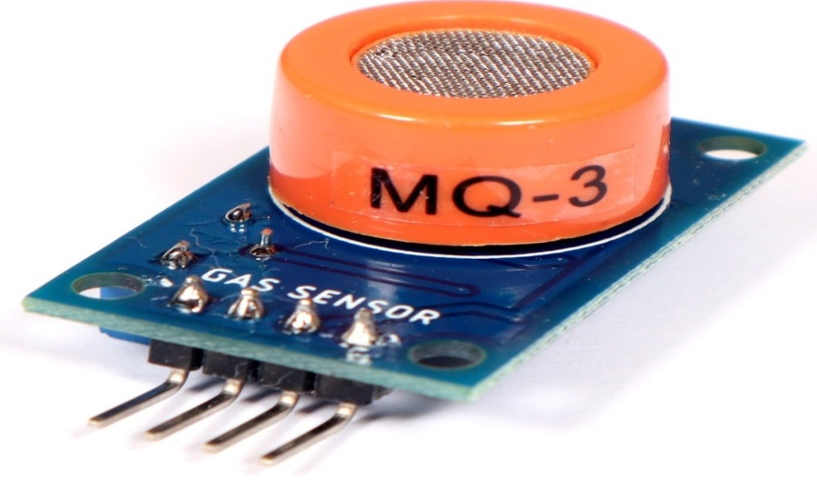
MQ3 sensor (Alcohol Sensor)
Fig 3 MQ3
MQ3 sensor is a special kind of sensor that can only sense the alcohol from the moisture in the air. the moisture content of alcohol can be detected by the sensor. inside the sensor, there is a metal electrode that can be activated when comes into contact with the alcohol.
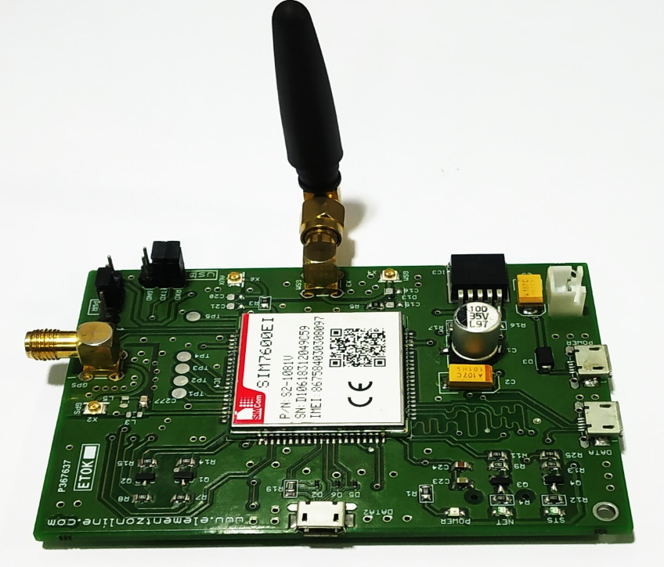
- SIM7600X
Fig 4 SIM7600X

The SIM7600 Series is Multi-Band LTE-TDD/LTE-FDD/HSPA+/TD-SCDMA and Dual-Band GSM/GPRS/EDGE module solution in a SMT type which supports LTE CAT4 up to 150Mbps for downlink data transfer.

- Arduino UNO
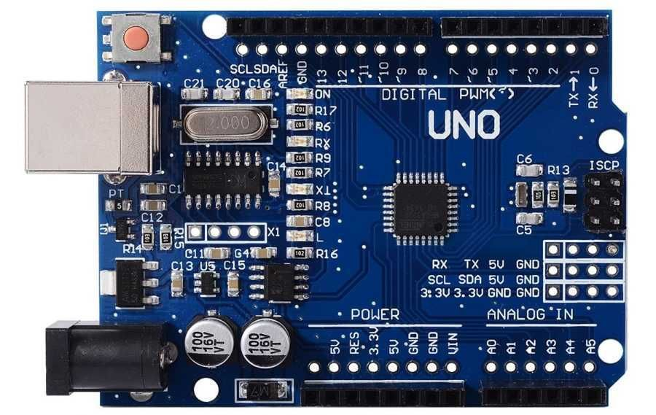

Fig 5 Arduino

The Arduino UNO is the best board to get started with electronics and coding. If this is your first experience tinkering with the platform, the UNO is the most robust board you can start playing with. The UNO is the most used and documented board of the whole Arduino family. Arduino UNO is a microcontroller board based on the ATmega328P. It has 14 digital input/output pins (of which 6 can be used as PWM outputs), 6 analog inputs, a 16 MHz ceramic resonator, a USB connection, a power jack, an ICSP header and a reset button.

- Male Jumper Wires

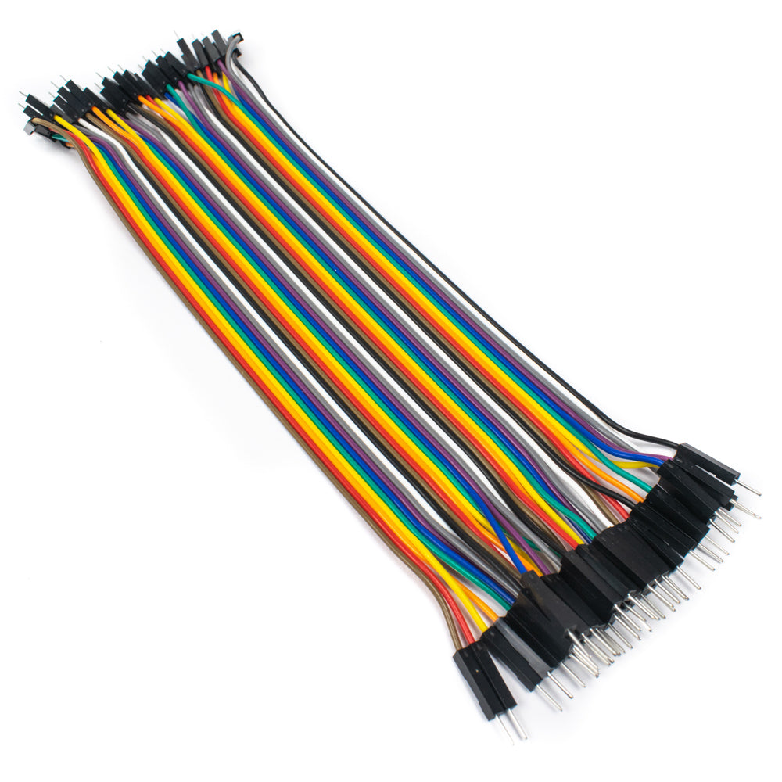

Fig 6 Male Jumper Wires

This has two ends where both male ends have a pin protruding and can plug into things. Male-to-male jumper wires are the most common and what you likely will use most often. When connecting two ports on a breadboard, a male-to-male wire is used. Features. It connects two points to each other without soldering.

